## 

**COLLEGE CODE: 8203**

**COLLEGE: AVC COLLEGE OF ENGINEERING**

**DEPARTMENT: INFORMATION TECHNOLOGY**

**STUDENT NM-ID: 4D2198FA90720AD8F834BBD4C69121C9**

**ROLL NO: 23IT100**

**DATE:15-09-2025**

**Completed the project named as Phase 2**

**TECHNOLOGY PROJECT NAME: Admin dashboard with charts**

**SUBMITTED BY,**

**NAME: Sivarajaganapathi S**

**MOBILE NO: 7845102808**

# Solution Design & Architecture

## Tech Stack Selection

| Component | Technology | Rationale |
| --- | --- | --- |
| **Frontend (UI)** | **HTML, CSS, JavaScript** (Frameworks like React/Vue optional) | To create a rich, dynamic, and responsive dashboard interface capable of rendering complex charts. |
| **Backend (API)** | **Node.js** with **Express.js** | A high-performance, non-blocking environment ideal for building fast and scalable RESTful APIs to serve data to the dashboard. |
| **Database** | **MongoDB** | A flexible NoSQL database that is excellent for storing application data, user metrics, logs, and easily retrieving/aggregating data for real-time charting. |
| **Visualization** | **Chart.js** | A lightweight, open-source JavaScript charting library to display dynamic and interactive line, bar, and pie charts on the frontend. |
| **API Client** | **Axios** (in frontend) | HTTP client used to reliably fetch metric data from the backend Node.js APIs. |
| **Security** | **JWT (JSON Web Tokens)** | To secure API endpoints and implement **Role-Based Access Control (RBAC)** to restrict data visibility. |
| **Design/Testing** | **Figma, Postman, Git/GitHub** | Tools for wireframing, designing, version control, and rigorous API testing. |

# UI Structure / API Schema Design

# UI Structure – Key Elements

* **Header**: "Admin Dashboard" with user profile and logout.
* **Sidebar Navigation**: Links to different metric views (e.g., Overview, Sales, Users, System Health).
* **Metric Cards**: High-level, real-time numerical summaries (e.g., Total Users: 5,000, Today's Sales: $1,200).
* **Chart Visualization Area**: The main area where dynamic charts are rendered using Chart.js.
  + **Bar Chart**: e.g., Sales by Product Category.
  + **Line Chart**: e.g., User Signups Over 30 Days.
  + **Pie/Doughnut Chart**: e.g., Traffic Source Distribution.
* **Role-Based Visibility**: Elements/charts are dynamically hidden or displayed based on the user's role (Admin, Manager, Analyst).

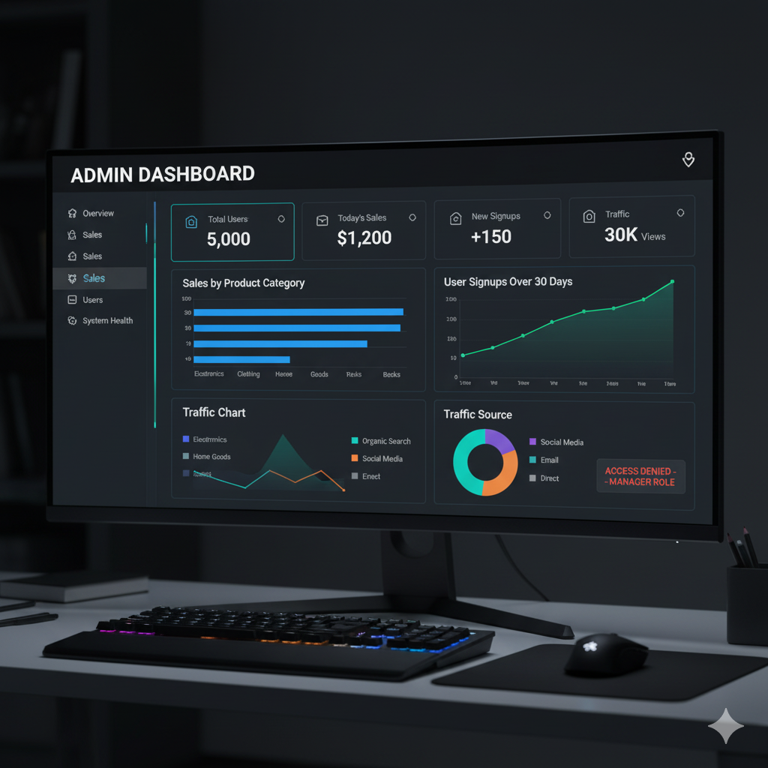

# API Schema Design (Core Endpoints)

| Endpoint | Method | Request Parameter | Successful Response Body (Example) | Error Response Body (Example) |
| --- | --- | --- | --- | --- |
| **/api/auth/login** | POST | username, password (body) | {"token": "jwt_string", "role": "Admin"} | {"error": "Invalid credentials"} |
| **/api/metrics/summary** | GET | **Header**: Authorization: Bearer <JWT> | {"totalUsers": 5000, "dailySales": 1200, "trafficSources": {...}} | {"error": "Unauthorized"} (401/403) |
| **/api/metrics/salesTrend** | GET | **Header**: Authorization: Bearer <JWT> | {"labels": ["W1", "W2", "W3"], "data": [1000, 1500, 900]} | {"error": "Access Denied"} (403) |
| **/api/metrics/userGrowth** | GET | **Header**: Authorization: Bearer <JWT> | {"labels": ["Jan", "Feb", "Mar"], "data": [500, 650, 800]} | N/A |

# Data Handling Approach

The system uses a direct API-to-Chart approach, leveraging MongoDB's aggregation pipeline for efficient data preparation.

1. **Authentication & Authorization**:
   * User logs in via /api/auth/login. The backend issues a **JWT** containing the user's **role** (e.g., 'Admin', 'Manager').
   * Every subsequent API call requires this JWT in the Authorization header. Express middleware checks the JWT validity and the associated role before granting access to data endpoints.
2. **Backend Data Computation (MongoDB/Express)**:
   * When an API (e.g., /api/metrics/salesTrend) is called, the Express handler triggers a **MongoDB aggregation pipeline**.
   * This pipeline processes large datasets (e.g., all sales records), performs computations (e.g., summing sales per week), and formats the output into a structure suitable for Chart.js.
3. **API Response Formatting**:
   * The backend ensures the response is a clean, chart-ready **JSON object** with labels (x-axis) and data (y-axis values).
   * Example: {"labels": ["Mon", "Tue"], "data": [10, 20]}.
4. **Frontend Data Rendering (Chart.js)**:
   * The frontend uses **Axios** to fetch the data from the secure API endpoints.
   * Upon successful retrieval, **Chart.js** initializes or updates the corresponding chart (line, bar, pie) using the labels and data arrays.
   * Charts are configured to **auto-update** every 30 seconds by repeating the API call.
5. **Error Handling**:
   * **401/403 Errors**: If a user without the necessary role attempts to access a protected endpoint (e.g., a 'Manager' accessing 'System Health'), the API returns a 403 Forbidden. The frontend redirects the user or displays an **"Access Denied"** message.
   * **500 Errors**: If the MongoDB connection or computation fails, the API returns a 500 Internal Server Error, and the frontend displays a general **"Dashboard data unavailable"** message.

# Component / Module Diagram

The system is logically divided into three main layers:

1. **Presentation Layer (Frontend UI)**:
   * **Dashboard Module**: Manages the overall layout and navigation.
   * **Chart Component**: Reusable components that encapsulate Chart.js logic (e.g., LineChartComponent, BarChartComponent).
   * **Auth Module**: Handles user login/logout and stores the JWT.
2. **Application Layer (Backend - Node.js/Express)**:
   * **Routes Module**: Defines API endpoints (/auth/login, /metrics/*).
   * **Auth Middleware**: Checks JWT and validates user roles for RBAC.
   * **Controller Module**: Coordinates between the Routes and the Service Layer.
   * **Metrics Service Module**: Contains the business logic for data retrieval.
3. **Data Layer (MongoDB)**:
   * **Database**: Stores all raw and transactional data.
   * **Data Access Layer (DAL)**: Contains functions for connecting to MongoDB and executing optimized queries/aggregation pipelines.

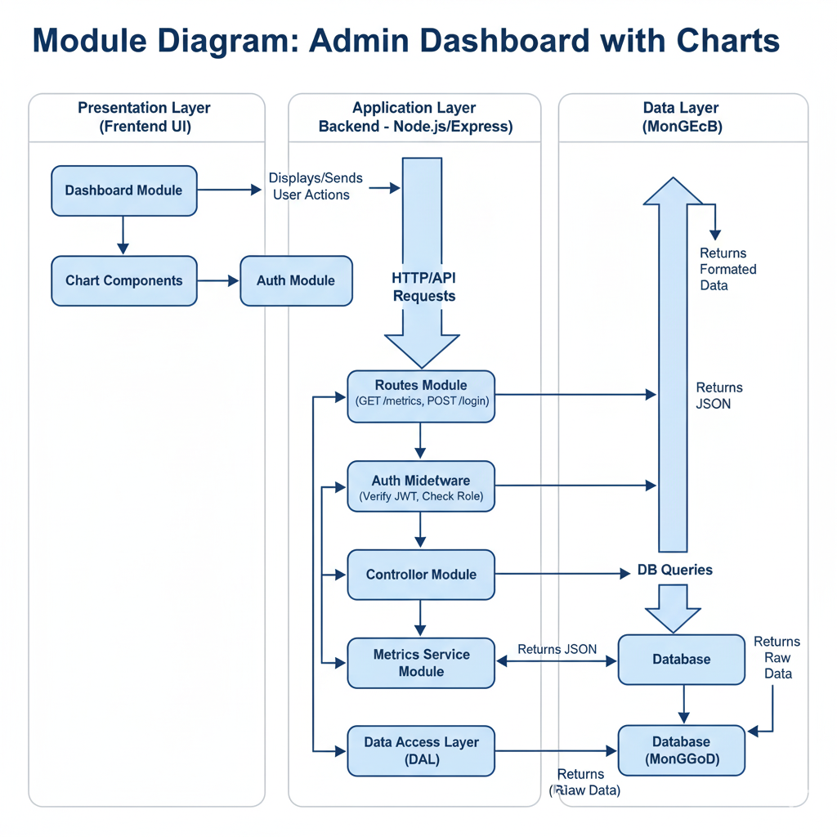

# Basic Flow Diagram

